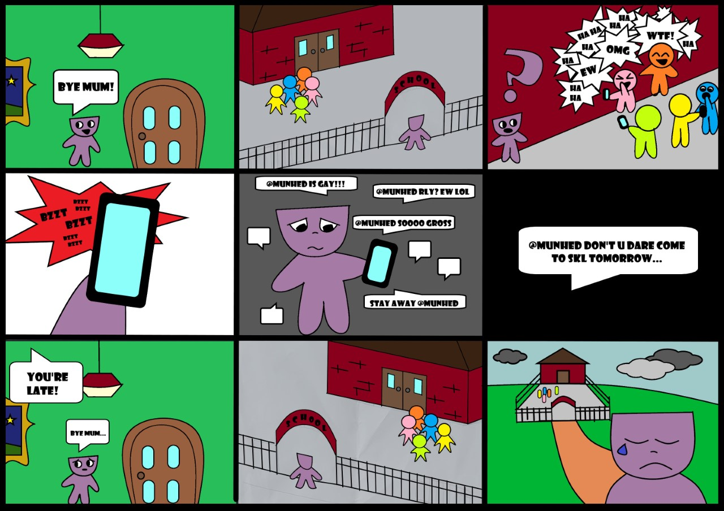
PROTECT PROJECT
Comic Strip and Prompt Questions for facilitation

Below is a comic strip depicting cyberbullying and associated prompt questions. This comic and questions can be used as part of sessions with children and young people, to invite thoughts and discussion on this topic.

QUESTIONS

- Who is the main character? Can you describe them?
- How do you think the main character feels in this story?
- Who are the other characters? Can you describe them?
- How do you think the other characters feel in this story?
- Which character would you like to be and why?
- Have you (or a friend, family member, or loved one) been in a situation similar to this one? If so, what happened? Can you describe how you felt and what you chose to do? Which character/s best shows you in this situation?
- What do you think the main (purple) character can do in this situation?
Is there anything that might make it difficult for the character to do this?
What would make it easier?
- Do you have any ideas on how to stop this situation from happening in the first place? What do you think schools, friends, families could do to help?

